The digestive system
The digestive system comprises the gastrointestinal tract and accessory organs. The gastrointestinal tract consists of the oral cavity, pharynx, esophagus, stomach, small intestine, and large intestine. The accessory organs are the teeth, tongue, and the glandular organs such as salivary glands, liver, and pancreas. The digestive system functions to provide digestion and absorption of food. The function of the digestive system is to digest and absorb food. Each of digestive system organs plays a specific role in the digestive system. The salivary glands in mammals are exocrine glands that produce saliva through a system of ducts. There are three pairs of major salivary glands as well as hundreds of minor salivary glands within the oral cavity: the parotid salivary glands, the sublingual salivary glands, and the submandibular salivary glands. These glands produce 1.0 - 1.5 liters of saliva each day. The discovery of the major salivary glands occurred between 1656 and 1685. In 1661, Nicholas Stenson (1638–1686) described the duct of the parotid gland. The origin of the complex drainage system of the sublingual gland was described by Caspar Bartholin (1655–1738) in 1685. The orifices of the submandibular salivary glands were first described by Thomas Wharton in 1656. In reality, Allesandro Achillini (1463-1512) had discovered these orifices before Wharton. Salivary glands can be classified as serous, mucous, or seromucous (mixed). The parotid glands produce serous secretions. Serous secretions (secretions enriched with proteins and water) are fluids resembling serum. The sublingual glands produce mainly a mucous secretion. However, it is categorized as a mixed gland. Mucous glands produce mucus. Mucus is a viscous, gel-like material consisting of various macromolecules (mainly mucin glycoproteins), inorganic salts, and water. Mucin absorbs water to form a sticky secretion called mucus. The secretion produced by the submandibular gland is a mixture of both serous and mucus fluid. Teeth have been considered as the most indestructible component in the human body because of protective layer covering them. The teeth provide a mechanical breakdown of food materials. The pharynx serves as a passageway of food material to the esophagus. This process is achieved by cranial nerves IX and X. The esophagus's primary function is to empty food materials into the stomach. The stomach has 3 muscular layers: an inner oblique layer, a middle circular layer, and an external longitudinal layer. The parietal cells secrete intrinsic factor and hydrochloric acid. The intrinsic factor is essential in the absorption of vitamin B12. The acidity of the stomach destroys most of the microorganisms. The acidity of the stomach is essential for the activation and function of pepsin. The chief cells produce pepsinogen. The mucous secretions in the stomach protect the gastric epithelium from acidic corrosion. Gastrin is produced by G-cells. Gastrin stimulates secretions from the parietal and chief cells. D cells produce somatostatin. Somatostatin inhibits the release of gastrin. 90% of food absorption occurs in the small intestine. The small intestine has three segments: the duodenum, the jejunum, and the ileum. The ileum is the last segment of the small intestine. The ileum has the ileocecal valve. The ileocecal valve controls the flow of material from the ileum to the cecum of the large intestine. The mucosa of the small intestine has villi. Each villus has multiple microvilli. The intestine has both endocrine and exocrine glands. Cholecystokinin (CCK), motilin, and secretin are produced by I-cells, M-cells, and S-cells in the upper small intestine, respectively. CCK was identified in 1966. CCK causes the release of bile from gallbladder and digestive enzymes from pancreas. Motilin is the most important factor in controlling the inter-digestive contractions. Secretin is a hormone that regulates the pH of the duodenum by inhibiting the secretion of gastric acid from the parietal cells of the stomach and by stimulating the production of bicarbonate from the ductal cells of the pancreas. It also stimulates bile production by the liver. The Brunner glands in the duodenum produce bicarbonate for acid neutralization. Accessory digestive organs such as the liver and the pancreas release secretions within the duodenum of the small intestine. The liver is the largest internal organ. The liver is the largest gland in the human body. The liver has numerous functions. The liver as an accessory organ of the digestive system produces bile. Bile emulsifies lipids for optimal digestion. Bile is stored in the gallbladder. The gallbladder contracts to release bile into the duodenum. The exocrine glands of the pancreas are essential for the food digestion process. The exocrine glands of the pancreas produce multiple enzymes. The large intestine absorbs water and electrolytes. Vitamin K is produced in the large intestine. The large intestine includes the appendix, cecum, colon, and rectum. The cecum is the first part of the large intestine. The colon consists of four parts: descending colon, ascending colon, transverse colon, and sigmoid colon. The rectum is the end of the large intestine. The peritoneum is a serous membrane. Mucous membranes are located in areas that are adjacent to the outside world (e.g., digestive, respiratory, urinary, and reproductive tracts). Serous membranes are found in the closed cavities that do not open to the outside (e.g., peritoneum, pleura, and pericardium). The peritoneum consists of two layers: the parietal peritoneum and the visceral peritoneum. The peritoneal cavity is a space between the parietal and visceral peritoneum.

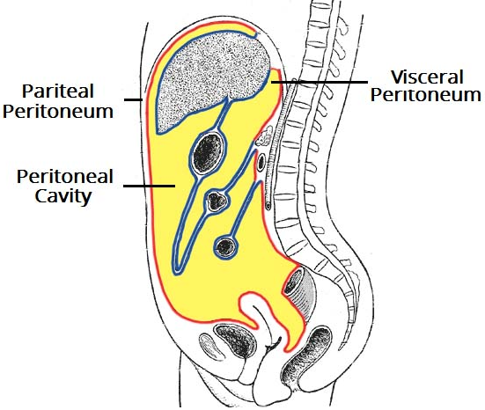

The intraperitoneal organs are stomach, bulb of duodenum, jejunum, ileum, cecum, appendix vermiformis, transverse colon, sigmoid colon, spleen, liver, gallbladder, and tail of pancreas. The retroperitoneal organs are oesophagus, the remainder of duodenum, ascending colon, descending colon, rectum, the remainder (head, neck, and body) of pancreas, kidneys, ureters, urinary bladder, adrenal glands, abdominal aorta, and inferior vena cava. Intraperitoneal organs are covered by visceral layer of peritoneum. No organ is not inside the peritoneal cavity. Organs that are intraperitoneal are usually mobile. However, organs in the retroperitoneum are usually fixed to the posterior abdominal wall.
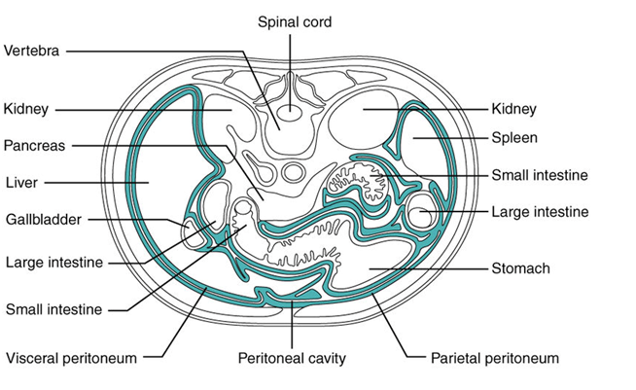

The mesentery is double layer of visceral peritoneum. The mesentery connects an intraperitoneal organ to the posterior abdominal wall. The mesentery provides a pathway for nerves, blood vessels, and lymphatics from the body wall to the viscera. Intraperitoneal organs have a mesentery. Mesentery related to the gastrointestinal system is named according to the viscera: mesogastrium, mesoappendix, transverse mesocolon, sigmoid mesocolon...
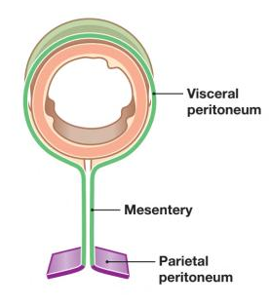
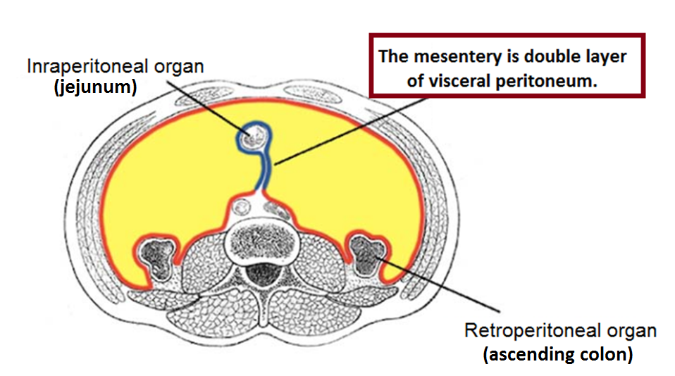

The omentum extends from the stomach and proximal part of the duodenum to other abdominal organs: greater (from stomach to transverse colon) and lesser (from stomach-duodenum to liver). The greater omentum consists of four layers of visceral peritoneum. The lesser omentum consists of the hepatogastric ligament and the hepatoduodenal ligament. The lesser omentum is a double layer of visceral peritoneum. The greater omentum has a role in immunity. The greater omentum can migrate to the site of inflammation.
